SNC2P

Lesson 6

Unit 2: Chemistry

Overall Expectations

By the end of this unit, students will:

- analyse how chemical reactions are employed in common products and processes, and assess the safety and environmental hazards associated with them;
- investigate, through inquiry, the characteristics of simple chemical reactions;
- demonstrate an understanding of simple chemical reactions and the language and ways to represent them.
Lesson 6 – Chemistry: Chemical Reactions and Their Practical Applications

Chemistry: A Definition

It is important to establish a clear definition of chemistry before continuing any further in this unit of study.

Chemistry is the study of matter, its properties, and its changes.

Matter is anything that has mass and takes up space.

Classifying Matter

John Dalton proposed an atomic model stating that all matter is made up of particles. When classifying matter today, scientists often break as seen below:

Matter

Pure
Substances
Mixtures

Solutions
Mechanical
Mixtures
Elements
Compounds

Pure Substances

- Contain only one kind of particle.
- For example, a piece of aluminium foil contains only aluminium particles.
- All samples have the same composition and properties.
- Its components cannot be separated by physical methods.
- There are two kinds of pure substances elements and compounds.
Elements

- Elements are pure substances that cannot be broken down by chemical means into a simpler substance.
- Each element can be identified by its own characteristic properties.
- The smallest particle in an element is the atom – it is the basic building block of all matter.
NOTE: Atoms join together in combinations. When 2 or more atoms join together, a molecule is formed.
- In elements, the atoms in a molecule will be all of the same kind.

Compounds

- Compounds are pure substances that contain 2 or more different elements combined in a fixed proportion.
- A molecule is the smallest part of a compound that still has the properties of that compound.

Mixtures

- Mixtures contain at least two different pure substances that can be separated by physical means.
- Mixtures are further classified by whether pure substances mix smoothly or unevenly when mixed together:

Solutions (Homogeneous Mixtures)

- If the pure substances mix very well with one another – so well that you can see only one phase or visible part – the mixture is called a solution. Ex. Salt and water.
- In a solution, one substance is dissolved in another.
- The substance that does the dissolving is called the solvent.
- The substance that gets dissolved is called the solute.

Mechanical (Heterogeneous Mixtures)

- If the pure substances don’t mix well with one another, you will see more than one phase – this type of mixture is called a mechanical mixture. Ex. Sand and water.

Physical Properties of Matter

Physical Characteristics are the characteristics that can be observed (using our senses) without changing the substance into another substance.

Physical Properties Observed Through Our Senses

COLOUR - Is it black, white, colourless, red, greenish-yellow…?

ODOUR - Is it odourless, spicy, sharp, burnt…?

TASTE - Is it sweet, sour, salty, bitter…?

TEXTURE - the feel of a substance to the fingers. Is it fine, coarse, smooth, gritty…?

LUSTRE - the ability of an object to reflect light. Is it shiny, dull…?

CLARITY - the ability of an object to transmit light. Is it transparent (clear), translucent (cloudy), or opaque (not allowing light through)…?

Other Physical Properties

PHYSICAL STATE - a substance can exist as a solid, liquid, or gas. Physical changes only alter the form of a substance; the chemical composition of the substance does not change.

MELTING & BOILING POINTS - the temperatures at which substances change state.

HARDNESS - is a measure of the resistance of a solid to being scratched or dented.

MALLEABILITY - the ability of a substance to be hammered or bent into different shapes.

BRITTLENESS - the ability of an object to break apart or shatter easily.

DUCTILITY - the ability of a substance to be stretched out into wires.

SOLUBILITY - the ability of a substance to dissolve in a solvent.

VISCOSITY - refers to how easily a liquid flows: the thicker the liquid, the more viscous it is.

Chemical Properties of Matter

Chemical properties are the characteristics that describe how a substance reacts with other substances to produce new substances.

Chemical Changes

Chemical changes transform a substance into something else.

The new substance (product) has physical and chemical properties different from the properties of the original substance (reactant).

The process by which a substance is changed into a new substance is called a chemical reaction.

Evidence That a Chemical Reaction Has Occurred
A new colour appears. | Heat or light is given off. | The change is difficult to reverse.
Bubbles of gas are formed. | A solid material (called a precipitate) forms in a liquid.

Support Questions

- Create a flow diagram in which you classify matter. Give an example of each.
- List and give examples of each of the physical and chemical properties of matter.

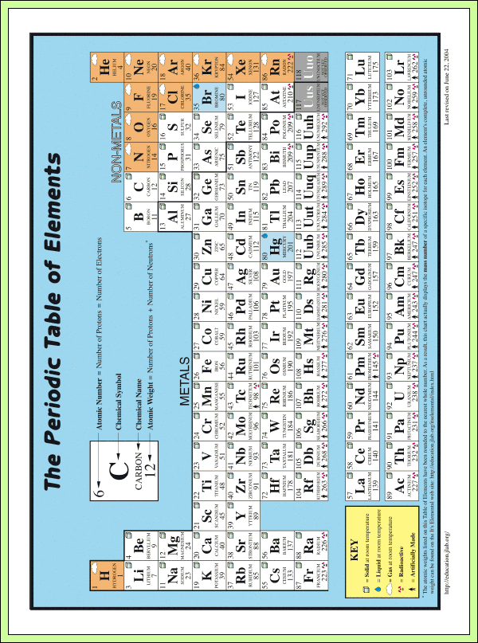

Alternate – use the Internet search engine – “periodic table” or go to ptable.com for an interactive version.
The Periodic Table of the Elements

The Periodic Table of the Elements is a structured arrangement of elements that helps us to explain and predict physical and chemical properties.

As a general rule, the periodic table is arranged with metals toward the left side. Non-metals are generally found on the right side of the table. The one exception is hydrogen that is found in the top left corner of the table.

Metals versus Non-metals

Property | Metals | Non-metals
Lustre | Shiny | Dull
Malleability | Malleable | Brittle
Conductivity | Conductors | Mostly Insulators
Reactivity with Acid | Mostly yes | No
State at Room Temperature | Mostly Solids | Solids, Liquids and Gases

Classification of the Elements

Metals are solid elements that are generally shiny, malleable and good conductors of heat and electricity. Non-metals are elements that are not good conductors of heat or electricity. Metalloids are elements that possess both metallic and non-metallic properties.

Organizing the Elements

A horizontal row across the periodic table is called a period. Elements are arranged in order of their atomic numbers. With a couple of exceptions, atomic masses increase in the same order as atomic numbers.

Groups of Elements

A column in the periodic table is called a group or chemical family.

Elements in the same family:
- have similar physical and chemical properties.
- have the same number of electrons in the outer shell.
- tend to form ions by gaining or losing the same number of electrons.

View a periodic table that identifies family groups at www.ptable.com

Alkali Metals

They are extremely reactive metals. The outer orbits have one electron – an unstable arrangement – so they tend to lose this electron, becoming ions with a charge of +1.

Alkaline Earth Metals

They are fairly reactive metals. The outer orbits have two electrons – so they tend to lose two electrons, becoming ions with a charge of +2.

Halogens

They are the most reactive non-metals. The outer orbits have seven electrons – so they tend to gain one electron in order to have a stable arrangement of electrons, forming ions with a charge of -1.

Noble Gases

They are very unreactive non-metals. They do not react with other elements because they already have a stable arrangement of electrons. They do not gain or lose electrons.

Ionic Charges and the Chemical Families

Elements in the same chemical family or group have the same valence value.

The valence value represents the number of electrons an atom of an element needs to gain or lose to have a complete outer shell – usually containing eight electrons (except for hydrogen and helium which need only two electrons for a complete outer shell).

When an atom has a complete outer shell, we say that it has a stable octet.

The valence value can help us determine how many atoms of each element need to be combined together to form a compound.

The valence values for the various families of elements are summarized below:

Group Number | Valence Value
1 | (+) 1
2 | (+) 2
3 | (+) 3
4 | (+/–) 4
5 | (–) 3
6 | (–) 2
7 | (–) 1
8 | None

UNOTEU: The charge represents whether electrons need to be gained or lost.

- A plus (+) means that electrons must be lost giving the atom a net positive charge (because there are more protons than electrons present).
- A minus (–) means that electrons must be gained giving the atom a net negative charge (because there are more electrons than protons present).

Chemical Families

Elements of the periodic table have been arranged in chemical families. Chemical families are groups of elements in the same vertical column of the periodic table. They tend to have similar physical and chemical properties.

On the far left column of the periodic table you will find the alkali metals. These include lithium, sodium, and potassium and are all shiny, silvery metals. Group two elements are known as the alkaline earth metals, and include calcium, magnesium and barium.

On the far left are the noble gases, such as helium, and neon. Generally, noble gases do not form compounds. The elements of the second to right column are called halogens. These non-metallic elements, include fluorine, chlorine and bromine. Halogens are all poisonous elements that react readily with sodium and other alkali metals.

Inside the Atom

Types of Subatomic Particles

The “pieces” of an atom – the particles of which an atom is composed – are called. They include:

- Protons which are positively charged particles with a relative mass of 1, located in the nucleus.
- Neutrons which are neutral particles with a relative mass of 1, also located in the nucleus.
- Electrons which are negatively charged particles with a relative mass of approximately 1/2000 of the mass of a proton or neutron, travelling in regions of space around the nucleus.

The Subatomic Particles of the Atom

Subatomic Particle | Location | Charge | Mass
Proton | Nucleus | Positive | 1
Neutron | Nucleus | Neutral | 1
Electron | Space Around Nucleus | Negative | 1/2000

Standard Atomic Notation

We can represent the numbers of subatomic particles using standard atomic notation.

In this notation, we write the chemical symbol of the atom and place the atomic number to the lower left and the mass number to the upper left.

Counting Subatomic Particles

Since atoms are electrically neutral, the positive charges on the protons are equalled by the negative charges on the electrons. Therefore, the number of electrons equals the number of protons.

Subatomic Particles
Element | Atomic Number | Mass Number | Number of Protons | Number of Electrons | Number of Neutrons
Hydrogen | 1 | 1 | 1 | 1 | 0
Helium | 2 | 4 | 2 | 2 | 2
Lithium | 3 | 7 | 3 | 3 | 4
Beryllium | 4 | 9 | 4 | 4 | 5
Boron | 5 | 11 | 5 | 5 | 6
Carbon | 6 | 12 | 6 | 6 | 6
Nitrogen | 7 | 14 | 7 | 7 | 7
Oxygen | 8 | 16 | 8 | 8 | 8
Fluorine | 9 | 19 | 9 | 9 | 10
Neon | 10 | 20 | 10 | 10 | 10
Sodium | 11 | 23 | 11 | 11 | 12
Magnesium | 12 | 24 | 12 | 12 | 12
Aluminium | 13 | 27 | 13 | 13 | 14
Silicon | 14 | 28 | 14 | 14 | 14
Phosphorus | 15 | 31 | 15 | 15 | 16
Sulphur | 16 | 32 | 16 | 16 | 16
Chlorine | 17 | 36 | 17 | 17 | 19
Argon | 18 | 40 | 18 | 18 | 22
Potassium | 19 | 39 | 19 | 19 | 20
Calcium | 20 | 40 | 20 | 20 | 20
Bohr’s Planetary Model of the Atom

Electrons move around the nucleus in circular paths called octets, like planets around the Sun.

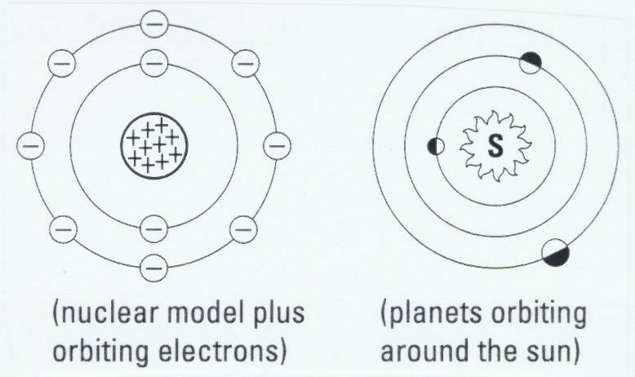

Electrons are spinning so fast in their orbits that they seem to form a solid shell around the nucleus.

Electrons cannot exist between these orbits, but can move up or down from one orbit to another. Electrons are more stable when they are at lower energy, closer to the nucleus.

Each orbit has a maximum number of electrons that it can hold.
The number of electrons found in the orbits of the first twenty elements:

1st orbit (K shell) – holds 2 electrons

2nd orbit (L shell) – holds 8 electrons

3rd orbit (M shell) – holds 8 electrons

4th orbit (N shell) – holds 2 electrons

Drawing Bohr-Rutherford Diagrams

To draw Bohr-Rutherford diagrams, use the following steps:

- Using the periodic table, determine the number of protons, neutrons, and electrons for the element.

- Draw a circle to represent the nucleus of the atom. The number of protons and neutrons are written inside this circle.

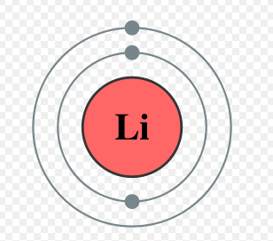
- Electrons are drawn in circular orbits around the nucleus. Remember that lower orbits will fill up first!

Support Questions

- Create a Bohr diagram for the following elements: Cl, O, H, Ag
- Describe the relationship between protons, electrons and neutrons.

Key Question #6 (29 marks)

- Chemists are always finding new materials that they can make from natural resources. These materials are taken by companies and sold as products that will appeal to consumers.

This week while you are watching TV, notice the chemical products that are being promoted. Pick one of these that can be found in your household to investigate. (20 marks)

Your investigation and report should include the following aspects:

- A description of the product’s advertisement. (e.g. What does the product promise? What methods are used to convince a person to buy the product?)
- List the chemicals (and formulas if available) of the ingredients in the product.
- Describe the properties of the chemicals.
- State how and where the product is produced.
- Describe any environmental problems with the product.
- State any hazards or warnings listed on the product.

- Create a Bohr diagram for magnesium, potassium and lithium. (9 marks)

SNC2P

Lesson 7

Lesson 7 – Writing Chemical Reactions

Charged Atoms

An ion is an atom that has become charged by gaining or losing one or more electrons.

These atoms have a charge because the number of electrons is not equal to the number of protons:

- If there are more electrons than protons, they form ions with net negative charges called negative ions
- If there are fewer electrons than protons, they form ions with net positive charges called positive ions.

For example, a neutral sodium atom (Na) has 11 protons and 11 electrons. If it loses an electron, it will form a positive ion because it now has 11 protons and 10 electrons (1 more proton than electrons).

Why Do Ions Form?

Atoms gain or lose electrons to form a stable octet. This refers to the outer electron shell being filled to its capacity.

How Elements Form Compounds

RECALL: Compounds consist of two or more elements that are chemically combined.
There are two main types of chemical bonds:

- Ionic bonds
- Covalent bonds

Ionic Compounds

Elements in the same families tend to form ions with similar ionic charges. Such an ionic charge may also be called the valence or combining capacity, of an element.

Metals and non-metals combine to form ionic compounds by transferring electrons.

The metal atoms lose electrons to form positive ions, and the non-metal atoms gain those electrons to form negative ions.

The result is a compound that is electrically neutral – the sum of the charges on the positive ions equals the sum of the charges on the negative ions.

An ionic compound is a substance that consists of positive ions and negative ions held together by electrostatic attractive forces.
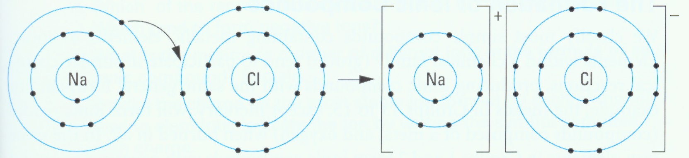
Writing Formulas for Ionic Compounds

Formulas can be predicted without drawing the atomic structure of the atoms involved in forming the ionic compound.

The steps involved in writing formulas and naming compounds are always the same.

Example 1:

What is the formula for the ionic compound formed by calcium and iodine?

Step 1: Write the symbols, with the metal first.

Ca I

Step 2: Write the ionic charge above each symbol to indicate the stable ion that each element forms.

2+ 1–
Ca I

Step 3: Determine how many ions of each type you need so that the total ionic charge is zero.

One Ca2+ ion will balance the charge of two I – ions.

Step 4: Write the formula using subscripts to indicate the number of ions
of each type.

The formula is CaB_{1B}IB_{2B} or CaIB_{2B}. The subscript “1” is unnecessary because the symbol itself represents one atom or ion.

The total ionic charge is (2+) + 2(1–) = 0.
Example 2:

What is the formula for the ionic compound formed by aluminium and sulphur?

Step 1: Write the symbols of the elements.

Al S

Step 2: Write the ionic charges.

3+ 2–
Al S

Step 3: Choose the number of ions to balance the charge.

The simplest way to do this is to apply the “Crisscross rule”: Crisscross the ionic charges written above the symbols such that the valence number of one element becomes the subscript on the other.

3+ 2–

Al S

Al2 SB_{3B}

The formula is AlB_{2B}SB_{3B}.

The total ionic charge is 2(3+) + 3(2–) = 0.

Naming Ionic Compounds

Rule 1: Write the name of the metal first and the non-metal second.

Rule 2: Change the ending of the non-metal to “ide”.

Example 1:
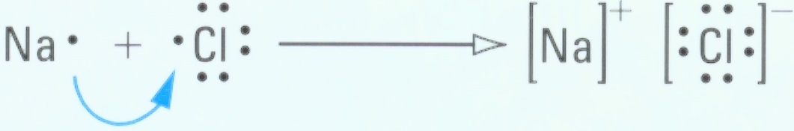

A sodium atom (Na) transfers an electron to a chlorine atom (Cl) to form a stable compound of sodium chloride (NaCl).

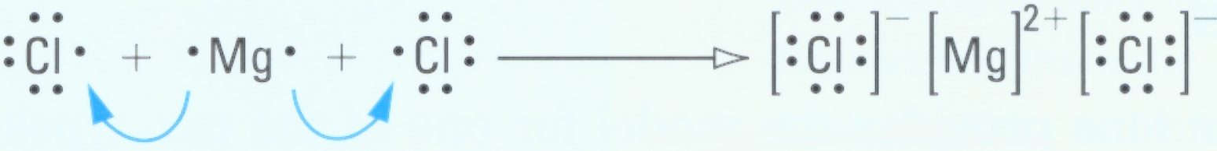
Example 2:

A magnesium atom (Mg) transfers electrons to two chlorine atoms to form a stable compound of magnesium chloride (MgClB_{2B}).

UTableU – Names and Ionic Charges of Some Non-metals

Name of element | Symbol | Ionic charge | Name in compound
fluorine | F | 1– | fluoride
chlorine | Cl | 1– | chloride
bromine | Br | 1– | bromide
iodine | I | 1– | iodide
oxygen | O | 2– | oxide
sulphur | S | 2– | sulphide
nitrogen | N | 3– | nitride
phosphorus | P | 3– | phosphide

Multivalent Elements

Some elements (mostly transition metals) have more than one valence and form more than one kind of ion. For example, Copper has an ionic valence of 1+ and 2+.

Chemists use the Stock system to name multivalent elements that form ionic compounds – Roman numerals are used to indicate the valence of the metallic element in the compound.

Write the chemical formula for the following:

Copper (I) chloride: CuCl

Copper (II) chloride: CuCl2

Names and Ionic Charges of Some Multivalent Elements

Name of element | Symbol | Ionic charge | Name in compound
copper | Cu | 1+, 2+ | I, II
iron | Fe | 2+, 3+ | II, III
lead | Pb | 2+, 4+ | II, IV
tin | Sn | 2+, 4+ | II, IV

Name the following ionic compounds using the Stock system.

SnClB_{4B}: Tin (IV) chloride

FeClB_{2B}: Iron (II) chloride

How do I know when to use the stock system when naming compounds?
The “Golden Rule”:

When the first element (the metal) is in Group 1 (Alkali Metals), or Group 2 (Alkaline Earth Metals), or is silver (Ag), Zinc (Zn), or aluminium (Al) – you do not use the stock system!

Polyatomic Compounds

Polyatomic ions are groups of atoms that tend to stay together and carry an overall ionic charge.

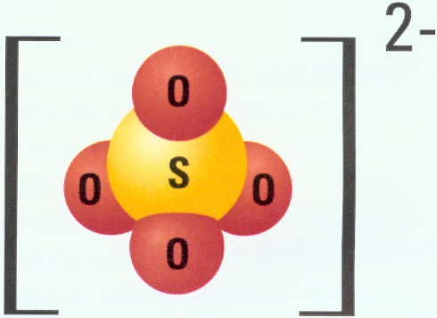
Examples: The nitrate ion The sulphate ion
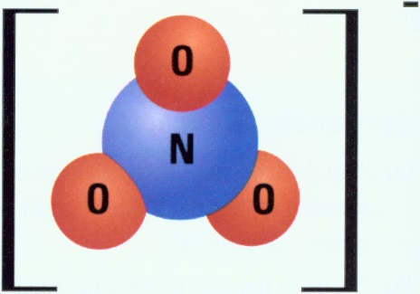

When a compound containing a polyatomic ion is dissolved in water, the metal ion separates from the polyatomic ion, but the atoms of the polyatomic ion stay together as a unit.

Common Polyatomic Ions and Their Ionic Charges

Name of polyatomic ion | Ion formula | Ionic charge
nitrate | NOB_{3B}– | 1–
hydroxide | OH– | 1–
bicarbonate | HCOB_{3B}– | 1–
chlorate | ClOB_{3B}– | 1–
carbonate | COB_{3B}2– | 2–
sulphate | SOB_{4B}2– | 2–
phosphate | POB_{4B}3– | 3–

Common Polyatomic Compounds

Compound | Formula | Use or source
calcium carbonate | CaCOB_{3B} | chalk and building materials
magnesium hydroxide | Mg(OH)B _{2B} | stomach antacids
sulphuric acid | HB_{2B}SOB_{4B} | car battery acid
copper (II) sulphate | CuSOB_{4B} | fungicide
Sodium carbonate | NaB_{2B}COB_{3B} | laundry detergents
ammonium nitrate | NHB_{4B}NOB_{3B} | fertilizer

Writing Formulas for Polyatomic Compounds

Since polyatomic ions have an overall charge and these molecules tend to stick together, they can bond with metals to form ionic compounds.

To name them, we use the same methods as we use with naming other ionic compounds.

Example 1:

What is the formula for the ionic compound formed by sodium and a sulphate ion?

Step 1: Write the symbols of the metal and of the polyatomic group.

Na SOB_{4B}

Step 2: Write the ionic charges above the symbols and crisscross them.

1+ 2–

Na SOB_{4B}

NaB_{2B} SOB_{4B}

Two Na+ ions will balance the charge of one SOB_{4B}2– ion.

Step 3: Write the formula using subscripts.

The formula is NaB_{2B}SOB_{4B}.

The total ionic charge is 2(1+) + (2–) = 0.

Example 2:

What is the formula for the ionic compound formed by magnesium and a phosphate ion?

Step 1: Write the symbols of the elements.

Mg PO4

Step 2: Write the ionic charges above the symbols and crisscross them.

2+ 3–

Mg POB_{4B}

Mg3 (POB_{4B})B _{2B}

Three Mg2+ ions will balance the charge of two PO43– ions.

Step 3: Write the formula using subscripts.

The formula is MgB_{3B} (POB_{4B})B _{2B}.

The total ionic charge is 3(2+) + 2(3–) = 0.

Naming Polyatomic Compounds

The name is simply a combination of the name of the metal and the name of the polyatomic ion.

For example, the chemical formulae for the following are:

Beryllium sulphate: BeSOB_{4B}

Lead (II) nitrate: Pb(NOB_{3B})B _{2B}

Aluminium hydroxide: Al(OH)B _{3B}

Copper (II) phosphate: CuB_{3B} (POB_{4B})B _{2B}

The following Ionic Compounds are:

KClOB_{3B}: Potassium chlorate

CaCOB_{3B}: Calcium carbonate

NaB_{2B}SOB_{4B}: Sodium sulphate

CuNO3: Copper (I) nitrate

Oxyacids

Oxyacids are compounds formed when hydrogen combines with polyatomic ions that contain oxygen.

The hydrogen has an ionic charge of 1+ in these compounds.

Table 3 – Common Oxyacids
Ion  Name | Ion  formula | Ionic  charge | Oxyacid  formula | Oxyacid  name
Nitrate | NO3– | 1– | HNOB_{3B} | nitric acid
Nitrite | NO2– | 1– | HNOB_{2B} | nitrous acid
Chlorate | ClO3– | 1– | HClOB_{3B} | chloric acid
Carbonate | COB_{3B}2– | 2– | HB_{2B}COB_{3B} | carbonic acid
Sulphate | SOB_{4B}2– | 2– | HB_{2B}SOB_{4B} | sulphuric acid
Sulphite | SO32– | 2– | HB_{2B}SOB_{3B} | sulphurous acid
Phosphate | POB_{4B}3– | 3– | HB_{3B}POB_{4B} | phosphoric acid

Note: The suffix –ate in a polyatomic ion denotes the most common number of oxygen atoms; while the suffix –ite always contains one less oxygen than in the –ate ion.

Naming Oxyacids

To name an acid with a polyatomic ion ending with the –ate suffix, drop the –ate suffix and add the suffix, –ic acid.

To name an acid with a polyatomic ion ending with the –ite suffix, drop the –ite suffix and add the suffix, –ous acid.

Molecular Compounds

Covalent bonds form when two or more non-metals share one or more pairs of electrons.

As a result of forming covalent bonds through sharing electrons, the atoms end up with a stable electron arrangement in their outer orbit similar to that of a noble gas.

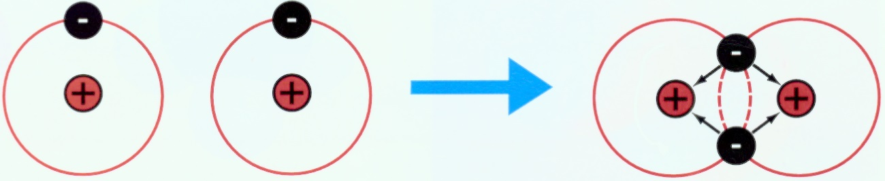

Example: Chlorine gas (ClB_{2B})

Chlorine gas is a molecule that consists of two chlorine atoms held together with a covalent bond.

Each chlorine atom has 7 electrons in its outer orbit and needs to gain 1 electron to become stable.

Two chlorine atoms share a pair of electrons to form a covalent bond. Each chlorine atom now has 8 electrons in its outer orbit (which forms a stable octet).

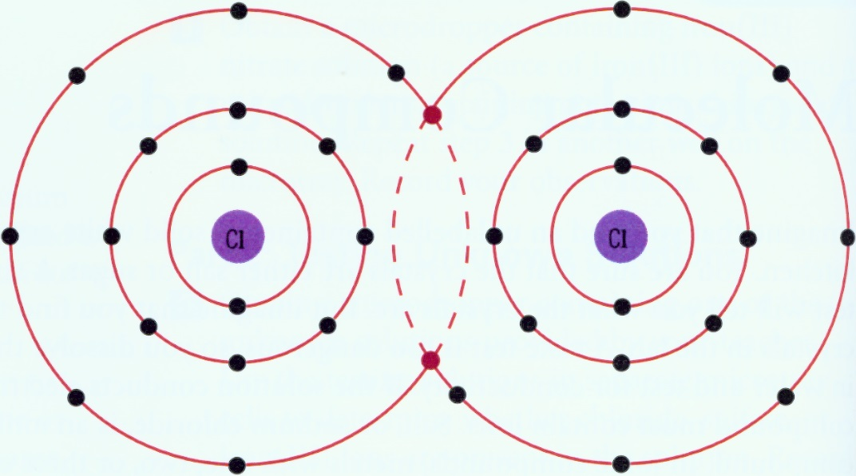
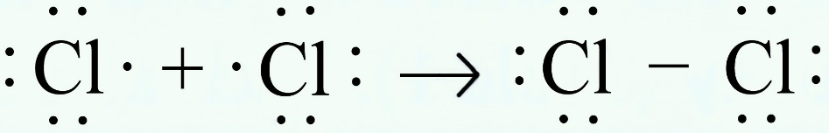

Other examples of covalently bonded molecules include:
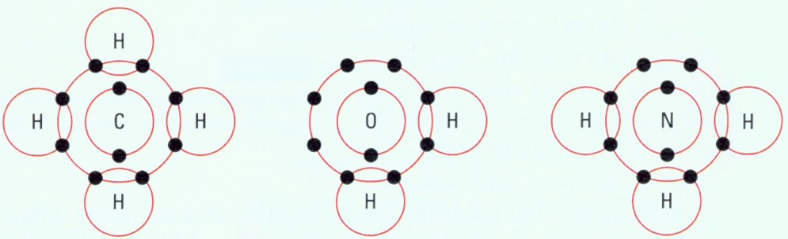

Methane (CH4) Water (H2O) Ammonia (NH3)

Classifying Molecular Compounds

Molecules can be classified by the number of atoms that they contain:
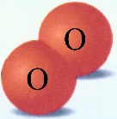
A diatomic molecule consists of 2 atoms of the same or different elements.

Elements That Form Diatomic Molecules
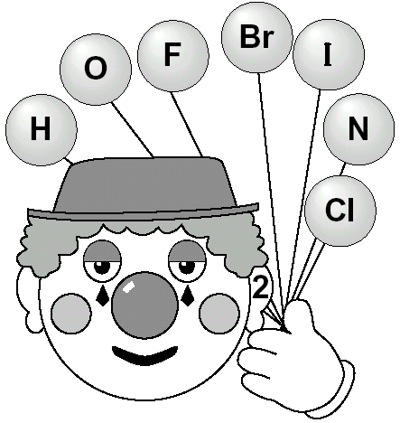
Name of  element | Chemical  symbol | Formula
hydrogen | H | HB_{2B} (gas)
oxygen | O | OB_{2B} (gas)
fluorine | F | FB_{2B} (gas)
bromine | Br | BrB_{2B} (liquid)
Iodine | I | IB_{2B} (solid)
nitrogen | N | NB_{2B} (gas)
chlorine | Cl | ClB_{2B} (gas)

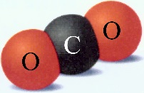
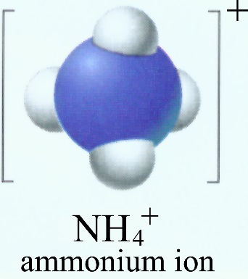
A polyatomic molecule consists of more than 2 of the same or different elements.

RECALL: It is possible for a cluster of atoms to be joined together by covalent bonds and yet have a charge.
These species are known as polyatomic ions.
Writing Formulas for Molecular Compounds

The combining capacity of a non-metal is a measure of the number of covalent bonds that it will need to form a stable molecule.

Combining Capacities of Non-metal Atoms

4 | 3 | 2 | 1
 |  |  | H
C | N | O | F
Si | P | S | Cl
 | As | Se | Br
 |  |  | I

You can use the combining capacity to write the formula of molecular compounds without having to consider electronic structure.

Example 1:

What is the formula for the molecular compound formed between carbon and sulphur?

Step 1: Write the symbols, with the left-hand element from Table 2 first, with the combining capacities.

4 2
C S

Step 2: Crisscross the combining capacities to produce subscripts.

4 2

C S

CB_{2B} SB_{4B}

The formula is CB_{2B}SB_{4B}.

Step 3: Reduce the subscripts if possible.

The formula CB_{2B}SB_{4B} can be reduced to CSB_{2B}.
Naming Molecular Compounds

The names of molecular compounds often contain prefixes. These prefixes are used to count the number of atoms when the same two elements form different combinations.

Prefixes in Molecular Compounds

Prefix | Number | Example (formula)
mono– | 1 | carbon monoxide (CO)
di– | 2 | carbon disulfide (CSB_{2B})
tri– | 3 | sulphur trioxide (SOB_{3B})
tetra– | 4 | carbon tetrafluoride (CFB_{4B})
penta– | 5 | phosphorus pentabromide (PBr5)

Rule 1: Write the name of the first element in the compound.
If more than one of that element is found in the formula, use the appropriate prefix.

Note: mono– is never used as a prefix for the first element, when only one of that element is present.

Rule 2: Change the ending of the second element to “ide” and use the appropriate prefix to denote the number of that element found in the formula.

Note: If the element begins with a vowel, and the prefix ends with the letter a, drop the letter a in the prefix.

Example, Name the following molecular compounds.

CO: carbon monoxide

COB_{2B}: carbon dioxide

NClB_{3B}: nitrogen trichloride

NB_{2B}FB_{4B}: dinitrogen tetrafluoride

PB_{2B}OB_{5B}: diphosphorus pentoxide

Exception to the Rule:

Some molecular compounds do not follow a naming system and are simply known by their common names: water (HB_{2B}O), ammonia (NHB_{3B}), hydrogen peroxide (HB_{2B}OB_{2B}) and methane (CHB_{4B}).
A Summary of Molecular and Ionic Compounds

 | Ionic Compounds | Molecular Compounds
Smallest particles | Cations and anions | Molecules
Origin of bonding | Electron transfer | Electron sharing
Forces between particles | Strong attractions between cations and anions  Strong repulsions between ions of like charge | Strong bonds between atoms  Weak attractions between molecules
Elements present | Metals and non-metals | Non-metals
Electrical conductivity | Good, when melted or dissolved | Poor
State at room temperature | Solid | Solid, liquid or gas
Melting and boiling points | Higher | Lower
Other names | Salts | Covalent compounds

A Summary of Writing Chemical Equations

How do we represent chemical reactions?

A word equation is one way of representing a chemical reaction: it tells us what reacts and what is produced.

RECALL: Reactants are the substances that you start with and products are the substances that you end up with.

Writing Word Equations

The left side of a word equation lists the names of all the reactants and the right side lists the names of all the products.

In every equation, an arrow is used to take the place of the word “yields” or “produces”:

all the reactants all the products

The reactants, as well as the products, are separated by a + sign:

reactant 1 + reactant 2 product 1 + product 2

Example: The word equation for the combustion of octane.

octane + oxygen carbon dioxide + water
Writing Chemical Equations

A chemical equation is a more conventional representation of a chemical reaction: it indicates the chemical formulas, the relative number and physical states of the reactants and products.

Example: The chemical equation for the combustion of octane conveys much more information:

2 CB_{8B}HB_{18 B}(g) + 25 OB_{2B} (g) 16 COB_{2B} (g) + 18 HB_{2B}O (g)

These numbers and letters are found in a chemical equation:
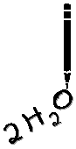
Coefficients

The large numbers in front of chemical formulas. Coefficients represent the number of molecules of the substance in the reaction.

Subscripts

The small numbers to the lower right of chemical symbols. These subscript numbers represent the number of atoms of each element in the molecule.

The small letters following the chemical symbols.
These subscript letters represent the physical state of each substance (solid, liquid, gas, or aqueous).

Symbols Used to Represent the Physical State of Elements and Compounds

State | Symbol
gas | (g)
liquid | (l)
solid | (s)
aqueous | (aq)

Note: Aqueous means that the substance is dissolved in water.

The Law of Conservation of Mass

This law states that in any chemical reaction, there is no detectable increase or decrease in the quantity of matter. Matter is neither created nor destroyed – the atoms of the reactants are simply rearranged into new and different groupings.

Example 1: Burning wood

Wood is made up of carbon, hydrogen, oxygen and some mineral matter. When it burns, it combines with oxygen to produce carbon dioxide, water vapour, some other gases and mineral ash.

mass of wood + mass of oxygen = mass of gases and ashes

Example 2: An iron key rusting

An iron key reacts with oxygen to form iron (III) oxide (rust).
The extra mass of the rusty key is due to the added oxygen.

mass of key + mass of oxygen = mass of rusty key

Balancing a Chemical Equation

A chemical equation provides quantitative information about a chemical reaction, but only if it is balanced. For a chemical equation to be balanced, the same number of each kind of atom must be present on both sides of the chemical equation.

We balance chemical equations largely by trial and error. There are a series of steps, however, that can help us get it right.

- Start with the word equation.
- Convert the word equation into a skeleton equation using formulas instead of names.
- If the equation contains a single element by itself, balance this type of atom at the end. The same rule applies if an element occurs in more than two substances in the equation.
- In the skeleton equation, pick out the formula with the largest number of atoms in it, and start from there.
- Balance atoms only by placing whole numbers in front of formulas. You cannot alter the formula.
- When finished, check to see that you have used the lowest whole numbers.
- If not, divide all the numbers by the highest common factor.

The Minnow Method

There is a particular order that you can follow in balancing equations. While shortcuts are possible, following these steps in order is the best way to be sure you are correct.

It is the MINOH (“minnow”) method:

Metals Balance metals such as Fe first

Ions Look for polyatomic ions (such as PO4 or SO4) that cross from
reactant to product unchanged. Balance them as a group.

Non-metals Balance non-metals such as Cl or S next.

Oxygen

Hydrogen

If the atoms are not balanced at this point, work your way back up the steps, from bottom to top, until you find the problem, and correct it.

NOTE: You cannot change a subscript to balance the equation, nor can you add in new compounds.

If every coefficient will reduce, rewrite in the simplest whole number ratio. An equation is not properly balanced if the coefficients are not written in their lowest whole number ratio.

Support Questions

Balance the following equations.

- HBrOB_{3B} + HBr HB_{2B}O + BrB_{2B}
- KOH + CrB_{2B}OB_{3B} + OB_{2B} KB_{2B}CrOB_{4B} + HB_{2B}O
- PbCB_{2B}HB_{5B} + OB_{2B} PbO + COB_{2B} + HB_{2B}O
- KMnOB_{4B} + HBr MnBrB_{2B} + BrB_{2B} + KBr + HB_{2B}O
- NaNOB_{3B} + Na NaB_{2B}O + NB_{2B}
- KClOB_{3B} KCl + OB_{2B}
- NHB_{4B}NOB_{3B} NB_{2B}O + HB_{2B}O
- CB_{4B}HB_{10B} + OB_{2B} COB_{2B} + HB_{2B}O
- CaO + C CaB_{2B}CB_{2B} + COB_{2B}

Key Question #7 (3 marks each = 27 marks)

Balance the following equations.

- CB_{6B}HB_{12B}OB_{6B} + OB_{2B} COB_{2B} + HB_{2B}O

- NaB_{3B}POB_{4B} + Zn(NOB_{3B})B _{2B} NaNOB_{3B} + ZnB_{3B} (POB_{4B})B _{2B}

- Al + COB_{2B} AlB_{2B}OB_{3B} + CO

- NHB_{3B} + OB_{2B} NO + HB_{2B}O

- (NHB_{4B})2CrB_{2B}OB_{7B} NB_{2B} + CrB_{2B}OB_{3B} + HB_{2B}O

- MnOB_{2B} + HCl MnClB_{2B} + ClB_{2B} + HB_{2B}O

- CrB_{2B} (SOB_{4B})B _{3B} + NaOH Cr(OH)B _{3B} + NaB_{2B}SOB_{4B}

- NHB_{3B} + OB_{2B} NB_{2B} + HB_{2B}O

- AlB_{4B}CB_{3B} + HB_{2B}O CHB_{4B} + Al(OH)B _{3B}

SNC2P

Lesson 8

Lesson 8 – Understanding Chemical Reactions

Combustion

What is the chemical reaction present when you strike a match? What further reactions happen when the match is brought close to a candle and the wax burns? Chemists use their knowledge of types of reactions to decide on the chemical composition of matches and to explain how these chemicals react.

Combustion is the very rapid reaction of a substance with oxygen to produce compounds called oxides. We often call this process burning. One way to represent combustion is using the following word equation:

Fuel + oxygen oxides + energy

Incomplete Combustion

Hydrocarbons can undergo a chemical reaction called incomplete combustion where there is not enough oxygen available for the reaction to take place. Instead of two products, four produces are produced: carbon monoxide, carbon, carbon dioxide, and water. Carbon monoxide is an odourless, colourless gas that is extremely poisonous. It combines with haemoglobin in the blood to starve the body of oxygen and cause death. The carbon sometimes produced in incomplete combustion is responsible for the black coating (soot) you find in fireplaces.

Chemical Reactions

There are four main types of chemical reactions:

Synthesis

Decomposition
The word “displacement” is
Single Replacement* often substituted for the word
Double Replacement* “replacement”.

Synthesis

Synthesis reactions involve direct combinations of 2 substances to produce 1 new substance:

A + B AB

You can often predict the formula of the product of a synthesis reaction involving elements if you know their valences.
Examples:

A metal and a non-metal form an ionic bond:

Na + Cl NaCl

A metal or a non-metal combines with oxygen to form an oxide:

2Mg + OB_{2B} 2MgO

C + OB_{2B} COB_{2B}

A metal oxide with water forms a base:

MgO + HB_{2B}O Mg(OH)B _{2B}

A non-metal oxide with water forms an acid:

COB_{2B} + HB_{2B}O HB_{2B}COB_{3B}

Decomposition

Decomposition reactions involve the breaking up of a compound into simpler substances:

AB A + B

A compound will separate into either elements or compounds.

These reactions are much harder to predict than synthesis reactions.

Examples:

Decomposition of water:

HB_{2B}O OB_{2B} + HB_{2B}

Decomposition of calcium carbonate:

CaCOB_{3B} CaO + COB_{2B}

Single Displacement Reactions

These reactions are also referred to as substitution reactions because one element replaces another in a compound:

X + AB A + XB

OR

Y + AB B + AY

Examples:

A metal replaces a metal:

Mg + 2AgNOB_{3B} 2Ag + Mg(NOB_{3B})B _{2B}

A non-metal replaces a non-metal:

BrB_{2B} + CaIB_{2B} IB_{2B} + CaBrB_{2B}

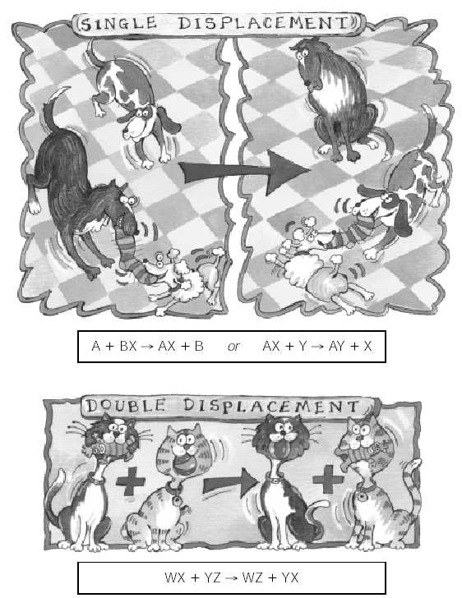
Double Displacement Reactions

These reactions are also referred to as substitution reactions because one element replaces another in a compound:

AB + XY AY + XB

Example:

Lead (II) nitrate + potassium iodide lead (II) iodide + potassium nitrate

Pb(NOB_{3B})B _{2B} + 2KI PbIB_{2B} + 2KNOB_{3B}

NOTE: In both single and double displacement reactions, metals exchange places with metals, and non-metals exchange places with non-metals.

Support Questions

- Classify each of the following as a single displacement or double displacement reaction:

- 2KI + Pb(NOB_{3B})B _{2B} PbIB_{2B} + KNOB_{2B}
- Fe + CuSOB_{4B} Cu + FeSOB_{4B}
- 2Li + HB_{2B}O 2LiOH + HB_{2B}
- Ca(OH)B _{2B} + 2HBr 2HB_{2B}O + CaBrB_{2B}
- Cu + 2AgNOB_{3B} 2Ag + Cu(NOB_{3B})B _{2B}
- (NHB_{4B})2SOB_{4B} + CaClB_{2B} CaSOB_{4B} + 2NHB_{4B}Cl
- ZnIB_{2B} + ClB_{2B} IB_{2B} + ZnClB_{2B}
- NaB_{2B}S + Pb(NOB_{3B})B _{2B} 2NaNOB_{3B} + PbS

Key Question #8 (29 marks)

- Complete the following reaction equation and balance it. (5 marks)

BiB_{2B}OB_{3B} + HB_{2B}

- Classify the reaction type below. (3 marks each = 24 marks)

  - Cu + HB_{2B}O CuO + HB_{2B}
  - Al(NOB_{3B})B _{3B} + NaOH Al(OH)B _{3B} + NaNOB_{3B}
  - KNOB_{3B} KNOB_{2B} + OB_{2B}
  - Fe + HB_{2B}SOB_{4B} FeB_{2B} (SOB_{4B})B _{3B} + HB_{2B}
  - OB_{2B} + CSB_{2B} COB_{2B} + SOB_{2B}
  - Cu + ClB_{2B} CuClB_{2B}
  - Mg + NB_{2B} MgB_{3B}NB_{2B}
  - C + OB_{2B} COB_{2B}

SNC2P

Lesson 9

Lesson 9 – Controlling Chemical Reactions

The Kinetic Molecular Theory

As particles, or molecules, move about, they hit or collide with each other. If the molecules are moving slowly or if they are very stable, the colliding molecules just bounce off one another → no reaction occurs (ineffective collisions).

However, molecules that collide with enough speed and energy may cause chemical bonds to break and re-form to make new molecules (effective collisions).

According to this collision model, there are 2 ways to make a reaction go faster:

↑ the number of collisions;
↑ the fraction of collisions that are effective.

Factors That Affect Rates of Reaction

There are 4 factors that affect the rate of reaction:

Temperature
Concentration
Surface Area
Presence of Catalysts

Temperature

Recall: The Particle Theory of Matter states:

↑Temperature =↑ Speed of Molecules =↑ # of Collisions =↑ Rate of Reaction

An increase in temperature makes the molecules collide more often and more effectively.

Concentration

When more molecules are packed into a smaller space, they are more likely to collide with each other.

↑ Concentration =↑ # of Collisions =↑ Rate of Reaction

Increasing the concentration of the reactants in a container increases the number of collisions between the molecules.

Surface Area

Surface area is the amount of area of a reactant that is visible and able to react. The surface area can be increased by decreasing the sizes of the pieces of the reactant.

How does this fit the collision model?

Reactions occur more quickly as the number of collisions between molecules increases. Increasing the surface area increases the number of collisions between molecules and therefore the rate of reaction.

↑ Surface Area =↑ # of Collisions =↑ Rate of Reaction

Catalysts

A catalyst is a substance that increases the rate of a chemical reaction without being consumed by the reaction. Thus, a catalyst is not a reactant.

A catalyst provides an easier way for a chemical reaction to occur. It does this by decreasing the amount of collision energy that molecules need to break bonds and form new molecules. A catalyst increases the fraction of collisions that are effective.

Support Questions

- Describe the job of a catalyst.
- Describe each of the four factors that impact the rate of reaction. How does each operate?

Key Question #9 (30 marks)

- Use the Internet or your local library to research how catalysts can be used in a) home, b) medicine, and c) industry. Describe your findings and how the catalyst works in a one page report. Include illustrations if applicable and make sure you list your references. (10 per catalyst – 30 marks total)

SNC2P

Lesson 10

Lesson 10 – Acids and Bases

Recognizing Acids and Bases

Why is it that some things are classified as acids and others as bases? Acids and bases are common chemical compounds that can be grouped according to their physical and chemical properties.

Acids

An acid is any compound that dissolves in water to release hydrogen ions (H +) and produce a solution having a pH lower than 7.

Properties of acids:
- They taste sour.
- They change the color of litmus paper from blue to red.
- They react with metals to liberate hydrogen gas. This general behaviour of acids can be summarized by this equation:

Acid + Metal Salt + Hydrogen

- They conduct electricity.

Common acids:
- Sulphuric acid – H2SO4
- Hydrochloric acid – HCl
- Acetic acid – CH3COOH (white vinegar)

Bases

A base is any compound that dissolves in water to release hydroxide ions (OH – ) and produce a solution having a pH greater than 7.

Bases are very corrosive; that is, they are capable of burning or damaging a number of materials including skin.

Properties of bases:
- They taste bitter.
- They change the color of litmus paper from red to blue.
- They feel slippery to touch.
- They react with acids to destroy its properties. This general property can be represented by this equation:

Acid + Base Salt + Water

- They conduct electricity.

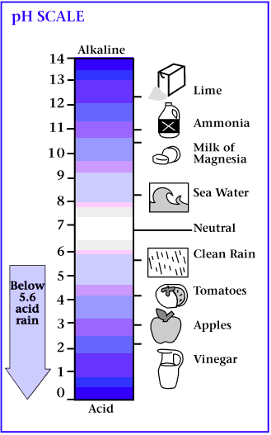
Common bases:
- Sodium hydroxide – NaOH (lye)
- Potassium hydroxide – KOH
- Magnesium hydroxide – Mg(OH)2
The pH Scale (Potential Hydrogen)

As concentrated acids and bases can be very harmful, chemists have come up with a scale to represent how acid or basic a product is. Something that is neutral has a pH of 7. The higher the acidity the lower the number. The stronger the base the higher the number

Neutralization Reactions

Acid-base reactions are also called neutralization reactions.
They are a special type of double displacement reaction.

Example:

hydrochloric acid + sodium hydroxide sodium chloride + water

HCl (aq) NaOH (aq) NaCl (aq) + HB_{2B}O (aq)

Support Questions

- Describe the properties of an acid and base. How do they differ?
- Why do we use the pH scale? Give five examples of items found on it.
- Create your own neutralization reaction. You may want to consult the Internet or a textbook for examples.

Key Question #10 (40 marks)

Which Antacid is the Best Buy? In this activity you will test different antacids to see which can neutralize the most acid. The antacid that neutralizes the most acid for the lowest price is called the “best buy”. Titration is an important laboratory procedure used in performing chemical analyses. In this acid-base titration, an acid is added to a weakly basic antacid tablet; the titration is stopped when the indicator changes colour, showing that the neutralization reaction is complete. Congo red indicator turns colour at a pH of 3, the normal pH in your stomach. Communicate your findings in a written report.

Materials
You must ensure you purchase a weak acid, like lemon, an over the counter indicator and a variety of antacid tablets.

Procedure
- Record the mass of an antacid tablet.
- Use a clean pestle to crush an antacid tablet in a clean mortar (figure 1).
- Add 50 mL of water to the mortar. Stir to dissolve the tablet, and then pour the contents of the mortar into a 250 mL flask. Rinse the mortar with another 50 mL of water. Again, pour the contents into the flask.
- Add 6 drops of Congo red indicator (or another indicator) to the flask.
- Carefully add your acid (the lemon), drop by drop, while gently swirling the flask over a sheet of white paper until the contents of the flask turn a light purplish blue (figure 2). Record the number of drops of acid neutralized by the tablet.
- Repeat steps 1 to 5 for a different brand of antacid.

Comparison
 | Tablet 1 | Tablet 2 | Tablet 3
Brand name
Mass of tablet used
Drops of acid required
Cost per tablet

Discussion
- Which antacid tablet neutralized the most acid?
- Calculate the number of drops of acid neutralized per gram of tablet. Which brand of tablet was the most effective per gram? Rank the tablets in order of effectiveness, with the most effective at the top of the list.

Note: Indicators may be found at a pharmacy. If you cannot get a liquid indicator, you may use pH strips and alter the method – rather than adding the indicator to the liquid, measure the pH of the liquid, add drops 2 at a time and re-measure the substance until a neutral measurement is achieved.
Support Question Answers

Lesson 6

- Classification of Matter

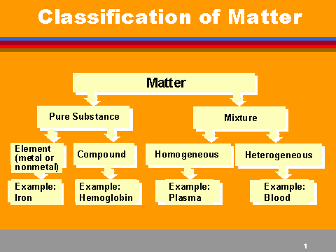

For examples – answers will vary.

- Chemical and Physical Properties of Matter

COLOUR - Is it black, white, colourless, red, greenish-yellow…?

ODOUR - Is it odourless, spicy, sharp, burnt…?

TASTE - Is it sweet, sour, salty, bitter…?

TEXTURE - the feel of a substance to the fingers. Is it fine, coarse, smooth, gritty…?

LUSTRE the ability of an object to reflect light. Is it shiny, dull…?

CLARITY the ability of an object to transmit light. Is it transparent (clear), translucent (cloudy), or opaque (not allowing light through)…?

PHYSICAL STATE a substance can exist as a solid, liquid, or gas. physical changes only alter the form of a substance; the chemical composition of the substance does not change.

MELTING & BOILING POINTS the temperatures at which substances change state.

HARDNESS is a measure of the resistance of a solid to being scratched or dented.

MALLEABILITY the ability of a substance to be hammered or bent into different shapes.

BRITTLENESS the ability of an object to break apart or shatter easily.

DUCTILITY the ability of a substance to be stretched out into wires.

SOLUBILITY the ability of a substance to dissolve in a solvent.

VISCOSITY refers to how easily a liquid flows: the thicker the liquid, the more viscous it is.

- Chlorine – Cl Oxygen – O
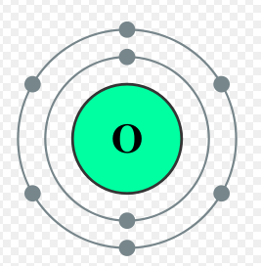
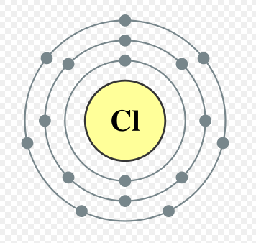

Hydrogen – H Argon - Ag
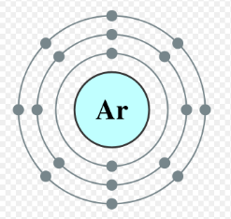
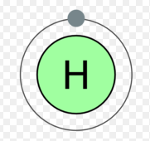

- Parts of the atom

- Protons which are positively charged particles with a relative mass of 1, located in the nucleus.
- Neutrons which are neutral particles with a relative mass of 1, also located in the nucleus.
- Electrons which are negatively charged particles with a relative mass of approximately 1/2000 of the mass of a proton or neutron, travelling in regions of space around the nucleus.

Lesson 7

- HBrO3 + HBr H2O + Br2

HBrOB_{3B} + U5U HBr U3U HB_{2B}O + U3U BrB_{2B}

- KOH + CrB_{2B}OB_{3B} + OB_{2 B} KB_{2B}CrOB_{4B} + HB_{2B}O

U4 UKOH + CrB_{2B}OB_{3B} + U3U OB_{2B} U2U KB_{2B}CrOB_{4B} + U2U HB_{2B}O

- PbCB_{2B}HB_{5B} + OB_{2B} PbO + COB_{2B} + HB_{2B}O

U4UPbCB_{2B}HB_{5B} + U15U OB_{2B} U4U PbO + U8U COB_{2B} + U10U HB_{2B}O

- KMnOB_{4B} + HBr MnBrB_{2B} + BrB_{2B} + KBr + HB_{2B}O

U2UKMnOB_{4B} + U16UHBr U2UMnBrB_{2B} + U5UBrB_{2B} + U2UKBr + U8UHB_{2B}O

- NaNOB_{3B} + Na NaB_{2B}O + NB_{2B}

U2 UNaNOB_{3B} + U4UNa U6UNaB_{2B}O + NB₂

- KClOB_{3B} KCl + OB_{2B}

U2UKClOB_{3B} U2UKCl + U3UOB₂

- NHB_{4B}NOB_{3B} NB_{2B}O + HB_{2B}O

NHB_{4B}NOB_{3B} NB_{2B}O + U2U HB_{2B}O

- CB_{4B}HB_{10B} + OB_{2B} COB_{2B} + HB_{2B}O

U2UCB_{4B}HB_{10B} + U13UOB_{2B} U8UCOB_{2B} +U10U HB_{2B}O

- CaO + C CaB_{2B}CB_{2B} + COB_{2B}

U2UCaO + U3UC CaB_{2B}CB_{2B} + COB_{2B}

Lesson 8

- Classify each of the following as a single displacement or double displacement reaction:

  - 2KI + Pb(NOB_{3B})B _{2B} PbIB_{2B} + KNOB_{2B} Double Displacement

  - Fe + CuSOB_{4B} Cu + FeSOB_{4B} Single Displacement

  - 2Li + HB_{2B}O 2LiOH + HB_{2B} Single Displacement

  - Ca(OH)B _{2B} + 2HBr 2HB_{2B}O + CaBrB_{2B} Double Displacement

  - Cu + 2AgNOB_{3B} 2Ag + Cu(NOB_{3B})B _{2B} Double Displacement

  - (NHB_{4B})2SOB_{4B} + CaClB_{2B} CaSOB_{4B} + 2NHB_{4B}Cl Double Displacement

  - ZnIB_{2B} + ClB_{2B} IB_{2B} + ZnClB₂ _{B} Single Displacement

  - NaB_{2B}S + Pb(NOB_{3B})B _{2B} 2NaNOB_{3B} + PbS Double Displacement
Lesson 9

- A catalyst is a substance that increases the rate of a chemical reaction without being consumed by the reaction. Thus, a catalyst is not a reactant.

A catalyst provides an easier way for a chemical reaction to occur. It does this by decreasing the amount of collision energy that molecules need to break bonds and form new molecules. A catalyst increases the fraction of collisions that are effective.

- Give examples of three catalysts often used in chemistry.

Some examples of catalysts are:

Manganese dioxide (a black powder) will catalyse the breakdown of hydrogen peroxide.
Car exhaust pipes use catalytic converters to get rid of some of the nasty gases from the engines.
Some catalysts are very expensive e.g. the platinum in a catalytic converter.
The lead in leaded petrol will poison the catalyst in a catalytic converter.

- Describe each of the four factors that impact the rate of reaction. How does each operate?

Factors That Affect Rates of Reaction

There are 4 factors that affect the rate of reaction:

Temperature
Concentration
Surface Area
Presence of Catalysts

Temperature

Recall: The Particle Theory of Matter states:

↑Temperature =↑ Speed of Molecules =↑ # of Collisions =↑ Rate of Reaction

An increase in temperature makes the molecules collide more often and more effectively.

Concentration

When more molecules are packed into a smaller space, they are more likely to collide with each other.

↑ Concentration =↑ # of Collisions =↑ Rate of Reaction

Increasing the concentration of the reactants in a container increases the number of collisions between the molecules.

Surface Area

Surface area is the amount of area of a reactant that is visible and able to react. The surface area can be increased by decreasing the sizes of the pieces of the reactant.

How does this fit the collision model?

Reactions occur more quickly as the number of collisions between molecules increases. Increasing the surface area increases the number of collisions between molecules and therefore the rate of reaction.

↑ Surface Area =↑ # of Collisions =↑ Rate of Reaction

Catalysts

A catalyst is a substance that increases the rate of a chemical reaction without being consumed by the reaction. Thus, a catalyst is not a reactant.

A catalyst provides an easier way for a chemical reaction to occur. It does this by decreasing the amount of collision energy that molecules need to break bonds and form new molecules. A catalyst increases the fraction of collisions that are effective.

Lesson 10

- Describe the properties of an acid and base. How do they differ?

Acids

An acid is any compound that dissolves in water to release hydrogen ions (H +) and produce a solution having a pH lower than 7.

PROPERTIES OF ACIDS:
- They taste sour.
- They change the color of litmus paper from blue to red.
- They react with metals to liberate hydrogen gas. This general behaviour of acids can be summarized by this equation:

Acid + Metal Salt + Hydrogen

- They conduct electricity.

COMMON ACIDS:
- Sulfuric acid – H2SO4
- Hydrochloric acid – HCl
- Acetic acid – CH3COOH

Bases

A base is any compound that dissolves in water to release hydroxide ions (OH – ) and produce a solution having a pH greater than 7.

Bases are very corrosive; that is, they are capable of burning or damaging a number of materials including skin.

PROPERTIES OF BASES:
- They taste bitter.
- They change the color of litmus paper from red to blue.
- They feel slippery to touch.
- They react with acids to destroy its properties. This general property can be represented by this equation:

Acid + Base Salt + Water

- They conduct electricity.

COMMON BASES:
- Sodium hydroxide – NaOH
- Potassium hydroxide – KOH
- Magnesium hydroxide – Mg(OH)2

- Why do we use the pH scale? Give five examples of items found on it.

As concentrated acids and bases can be very harmful, chemists have come up with a scale to represent how acid or basic a product is. Something that is neutral has a pH of 7. The higher the acidity the lower the number. The stronger the base the higher the number

Examples of items found on the pH scale are milk, water, lemon juice, battery acid and ammonia.

- Create your own neutralization reaction. You may want to consult the Internet or a textbook for examples.

Acid-base reactions are also called neutralization reactions.
They are a special type of double displacement reaction.

Example from your learning:

hydrochloric acid + sodium hydroxide sodium chloride + water

HCl (aq) NaOH (aq) NaCl (aq) + HB_{2B}O (aq)

Some other examples of neutralization reactions:
HCl + NaOH --> NaCl + HOH
HB_{2B}SOB_{4B} + 2 NHB_{4B}OH --> (NHB_{4B})B_{2B}SOB_{4B} + 2 HOH
2 NaOH + HB_{2B}COB_{3B} --> NB_{2B}COB_{3B} + 2 NaOH

